Academic Task Number: CA-2 (Test-1) SET-B Course code: ECE-249 Section: K22
Date of allotment: Course title: BEEE Roll No.
Date of submission: Maximum Marks: 30 Reg. No.
Academic Task Type: Subjective
Q. No. | Question Statement | Course Outcome | Bloom’s level | Marks
Q1 | - Define RMS and average value of current. Write the formula to determine these values.  - Draw power triangle with units. | CO1 | L1: Remember | 5
Q2 | Find V_{R} and V_{L} and the Impedance; also calculate the power factor and instantaneous power of the given circuit?  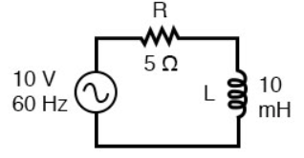 | CO2 | L3: Apply | 5
Q3 | a) Define Maximum power theorem.  b) Find also the value of the maximum power and the power supplied by source under these conditions.  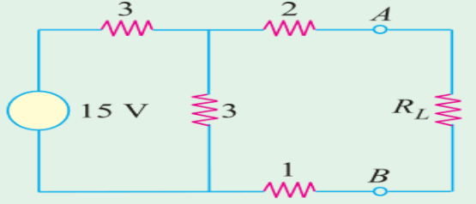 | CO1 | L1:Apply | 5
Q4 | - Determine the currents I₁, I₂ and I₃ following the parallel branches in the network shown in figure.  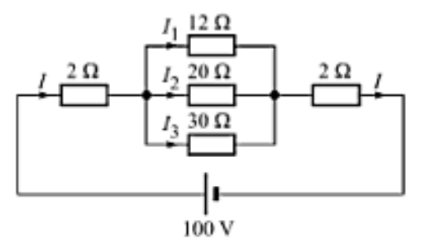 | CO1 | L3: Apply | 5
Q5 | A sinusoidal voltage supply defined as: V(t) = 110 x cos(ωt + 40º) is connected to a pure resistance of 65 Ohms. Determine its impedance and the peak value of the current flowing through the circuit. Draw the corresponding phasor diagram. | CO1 | L1:Apply | 5
Q6 | Discuss Norton’s theorem with one example. | CO1 | L3: Remember | 5

